A Newsletter to Parents


BRIDGEWATER HIGH SCHOOL
Monday, 4th February 2008 – Special school holidays issue

Acting Principal: Mrs Chris Gee

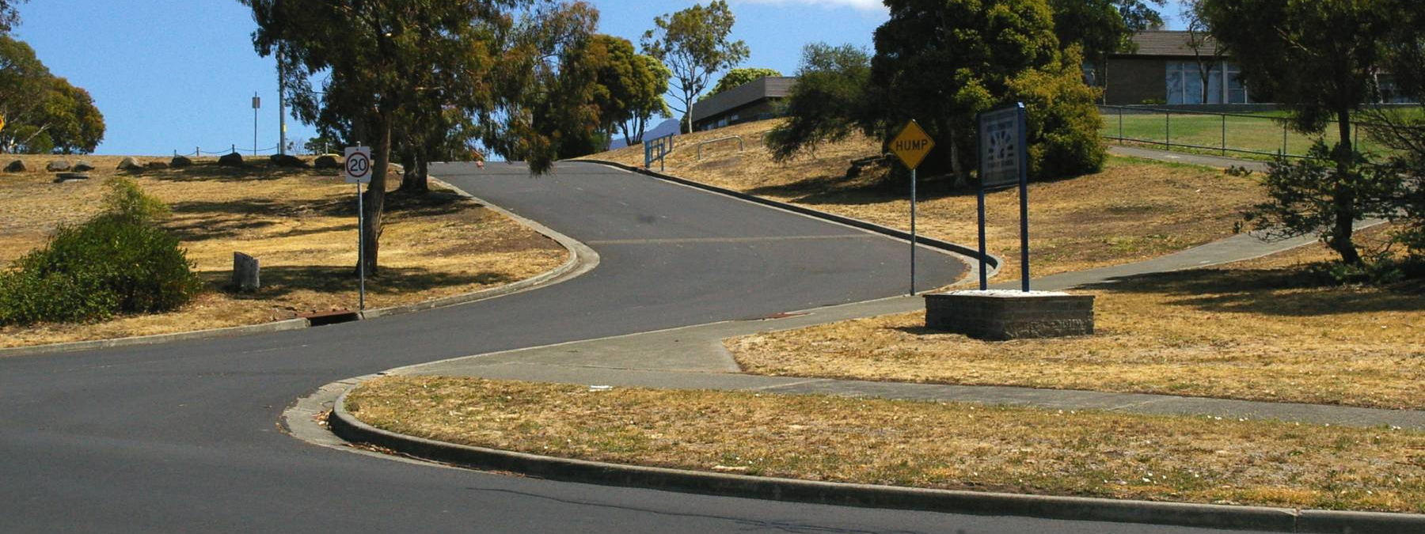

Attention parents and members of the wider community

ROAD TO THE FUTURE: The Eddington Street entrance to Bridgewater High School at the former Bridgewater Primary School site.
Builders are doing a great job altering the Bridgewater Primary building, making it ready for our use as a high school.
But this year's changeover also means some differences in procedures for uniform sales, stationery (book sales) and phoning the school – and a later term 1 commencing date.
 SEE DETAILS INSIDE
Bridgewater and Southern Midlands Education Renewal Taskforce (BASMERT)
Community Update Number 2 from BASMERT is reproduced on the back page for your convenience
BRIDGEWATER HIGH SCHOOL Info Monday, 4th Feb. 2008 Page 2

A HOLIDAYS INFO
This special issue of Info is being distributed through local shops and other locations during the holidays.
We are keen to make sure that parents are aware that:
- uniform sales will be held this Thursday, 7 February, at the PCYC
- there is a temporary phone number for Bridgewater High: 0407 053 690
- there are no book sales during the holidays this year, and
- Term 1 begins on the delayed date of Monday 18 February.
This information has been publicised on our website and through emails to students with email accounts from last year, and is contained in a mailout to parents and guardians from the school office last Friday.
However, we are concerned that some parents, particularly those who have changed their address recently, might not receive the information in time for the uniform sales in particular.
We hope you appreciate our efforts to reach you!
The builders are doing a wonderful job getting the Bridgewater Primary building ready for use as a high school.
I look forward to seeing students and their parents there in Term 1.
- C Gee

On Friday last week, 1 February, the school office posted to parents and guardians an envelope containing:

- a uniform price list
- a validation form (containing information such as who is to be contacted if a child becomes ill)
- an invoice for levies for those not on STAS (the Student Assistance Scheme)
The levy for 2008 is $350. Arrangements for paying by instalments can be made with the School Executive Officer, Tanya Kerfoot, at the start of the year.
Levies can be paid at the time of the uniform sales or from the start of the school year on 18 February.
Uniform and levy payments: no EFTPOS
At this stage we do not have EFTPOS facilities.
Payments can be made only by cash or cheque.

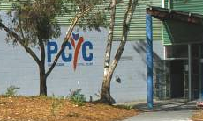
BRIDGEWATER HIGH SCHOOL Info Monday, 4th Feb. 2008 Page 3

DATES
Friday | 1 February 2008 | Mailout to parents.
Thursday | 7 February 2008 | Uniform sales, 10am-2pm - at the PCYC, Greenpoint Road.
Monday | 11 February 2008 | Regatta Day holiday.
Tuesday | 12 February 2008 | Teachers resume.
Thursday | 14 February 2008 | No longer the first day of Term 1 for students. See 18 February.
Monday | 18 February 2008 | First day of Term 1 for students. Arrive by 8.30am.  Students receive stationery packs.

Please use 0407 053 690 (or 0408 542 960) for now.
If you wish, you can ask to be phoned back to avoid the time-based costs that can result from phoning a mobile number.
Our normal number (6263 7131) can't be connected to us yet. The Claremont College staff who are kindly answering calls to 6263 7131 are able to tell you the above mobile number, but they are unable to transfer the call.

The PCYC in Greenpoint Road
Uniform sales will be held on Thursday this week, 7 February, from 10am to 2pm at the PCYC in Greenpoint Road.
Please enter through the back entrance beside the supermarket car park.

Term 1 start
Bridgewater High School students will return to school on Monday 18 February 2008 instead of 14 February, the date for other high schools.
The delay of two school days is to enable staff to complete final preparations for holding high school classes at the newly altered site.
(Students at Bridgewater Primary and Green Point Primary have the same delayed start to 2008, both schools commencing at Green Point Primary School on Monday 18 February.)
All students will receive stationery packs when they return on Monday 18 February 2008.
Unlike what has happened in previous years, there will be no "book sales days" during the holidays.

New enrolments are most welcome.
Please phone 0407 053 690 to make arrangements.
School website – latest news
Keep up to date by checking our news page:
www.bhs.tased.edu.au/news

BRIDGEWATER HIGH SCHOOL Info Monday, 4th Feb. 2008 Page 4

Bridgewater and Southern Midlands Education Renewal Taskforce
Examining educational options following the Bridgewater High School fire
Community Update No. 2 – January 2008
The Taskforce met for a third time on Wednesday 16 January. Here are a few points about that meeting:
- Three of the four local councils in our area presented their view of the future for the whole sub-region.
- Siobhan Gaskell, Director of the State Library of Tasmania, talked to us about lifelong learning and introduced Pip Hankin who described the operation and success of the Huon LINC (Learning and Information Network Centre) project.
- Mark Sayer, General Manager of Skills Tasmania, gave a presentation about participation in the workforce.
- We were given details of the plans for the Focus Groups. Basically 73 members of our community have been selected at random and have been invited to participate in discussions about the future of education in the area. There will be five Focus Groups between 31 January and 5 March and they will be run by an independent consultant, Janine Coombes. There will be a sixth session for randomly selected teachers from our area.
- In addition to these Focus Groups it was decided to have a Public Workshop for up to 100 people. We are still working on details of this workshop but we hope to have an independent consultant run this for us and it will probably happen in mid to late February. More details on all of this soon.
- The next meeting of the Taskforce will be with Brian Caldwell, an educator with an international reputation, on Thursday 7 February.
Should you wish to ask questions about any of this or make a comment, please do so by e-mail to david.forshaw@education.tas.gov.au.
Until BASMERT has its own website set up, information will be available at www.bhs.tased.edu.au/taskforce.
INFORMATION FROM BASMERT REPRODUCED BY BRIDGEWATER HIGH SCHOOL
AS A SERVICE TO OUR PARENTS AND THE WIDER COMMUNITY

